SWMS Business Case Proposal

|  |  |  |
| --- | --- | --- |
| Proposal Title |  | Sponsor |
| **Automate Waste Collection Calendar** |  | **Charlotte Ueta** |
|  |  |  |
| Project Manager |  | Division Head |
| **Lionel Coelho** |  | **Rob Orpin** |

# EXECUTIVE SUMMARY

* The Solid Waste Management Services division is responsible for collecting waste for over 1M homes.
* Depending on where a resident lives in the City, their waste is collected on a specific day of the week.
* Residents can download their collection calendar from the SWMS website.
* The Curbside Collection page is one of the most visited webpages under the SWMS domain, and indeed, also under the Toronto.ca domain.
* It cannot be overstated how critical the Curbside Collection page is in terms of the information it delivers to the public. Here are supporting statistics (2015):

**3 mins**

Length of time spent on page

**#3**

Rank out of 615 SWMS webpages

**312,747**

# of page views in 2015

**#36**

Rank out of 20,000 Toronto.ca webpages

# PROBLEM

* With the current implementation, a resident finding their collection calendar is likened to that of a mouse in a maze.
* Finding a collection calendar requires a resident:
  + Manually identify the district they reside in by visually examining a map.
  + Once they locate their district they must click on it which brings up another map in .PDF format.
  + Resident must further study the maps borders and colour codes to locate the Collection Area they reside in.
    - Note: Some residents live in areas which requires they open a third .PDF map.
  + Resident then clicks on their Collection Area which loads the relevant collection calendar for download.
* A further complication for residents is determining which of the 3 customer groups they belong to. Each of which have their own webpages.
* Figure 1 shows the process breakdown:

**Figure 1:**

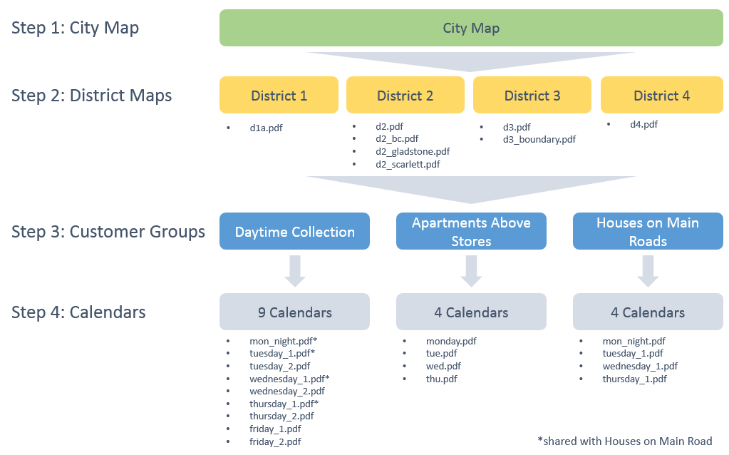

* The 2015 stats bears out that the average resident spends an excessive 3 minutes obtaining their collection calendar.
* Furthermore, the process is largely not AODA compliant; leaving this critical information out of reach for many residents and puts SWMS in non-compliance with the AODA mandate.
* As it is used by 100,000's of residents a year, the current implementation of obtaining collection calendars needs a change. We believe it is important that the City and SWMS provide a smooth and positive experience for residents looking to find out when to take out their waste bins.

# RECOMMENDATION

* Build a simple tool for residents to quickly find their collection calendar.
* The tool shall allow a resident to search an address and instantly be presented with the next two (2) upcoming waste pickup dates, accepted items on each date, and the annual collection calendar for download.
* Figure 2 is a mock-up of the tool:

**Figure 2:**

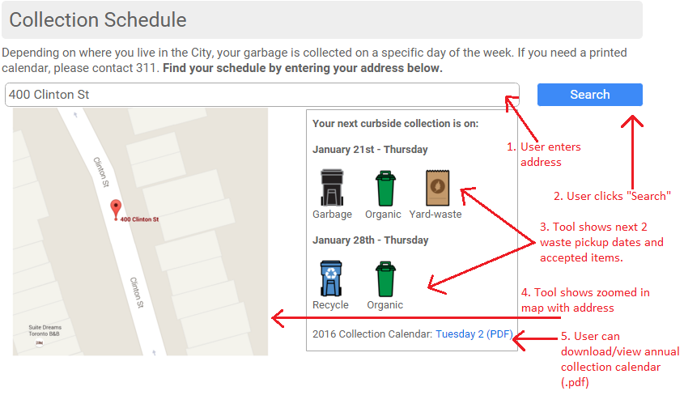

* The tool reads a static data file extracted from the TMMS database. The data file contains the collection calendar to be used for all properties in the City.
* The tool will be the placed on the "Houses" tab within the new SWMS website, and also in the "Apartments and Condos" tab.

# EXECUTION

There are 3 primary elements needed for the business case to be executed successfully.

**TMMS DATA FILE**

* TMMS will provide a data file containing addresses for each of the 4 districts covered by SWMS collection services.
* The data file crucially shows the collection calendar associated with each address.
  + Total addresses as of Nov. 2015 = 482,060
  + 13 unique calendars
* The SWMS website administrator shall be able to upload a new TMMS data file as needed.
* Figure 3 shows sample data from TMMS.
  + Note: TMMS has all waste related data for each property in the City. Additional data can be added to this file, and format, headings, etc. can be modified as needed.

**Figure 3:**



**COLLECTION CALENDAR TOOL**

* A tool with mapping capabilities is required. See Figure 2.
* The web-based tool shall work within the City's WCM framework.
* It is preferred the tool uses Google Maps and presents relevant address options in a dropdown as the user types in the address search bar.
* It should be noted that the TMMS dataset does not contain the waste types accepted for each day in the year. Instead, it shows the collection calendar associated with each property. See Figure 4 for sample collection calendars.

**Figure 4:**

|  |  |
| --- | --- |
| *tuesday_1.pdf* | *ruac-thu.pdf* |

* **Option 1:** The tool will require logic to determine the waste types accepted on specific dates.
  + For example:
    - Rule: Waste collection alternates weekly between Garbage and Recycling.
    - Rule: Organics are picked up every week.
    - Rule: Christmas Trees are only accepted on the 2nd and 4th pickup of the year.
    - Rule: Waste collection for properties using the Tuesday_1 calendar begins on the first Tuesday of the year, with Recycling and Organic waste accepted.
    - Scenario: Resident inputs 11 Miles Rd. into the tool on Jan 23rd
    - Operation: TMMS data indicates **11 Miles Rd** uses collection calendar **Tuesday_1.pdf**
    - Result: Tool determines the next collection date is **Jan 26th** and Accepted Items are **Garbage, Organic, and Christmas Tree**. The following collection date is **Feb 2nd** and Accepted Items are **Recycling and Organic**.

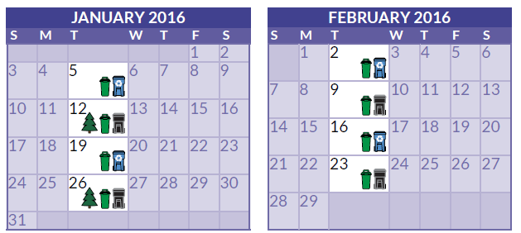

* **Option 2:** A data file is created to represent each collection calendar; the tool would utilize this data instead of relying on programmed rules.
* The data file would be updated annually if any change to the calendar is needed, and uploaded to WCM for the tool to refer to at the start of the new year.
  + Figure 5 is an example of collection calendar for Friday 1.

**Figure 5:**



**ADMIN PROCESS**

* TMMS staff provide SWMS website administrator an updated data file either quarterly, semi-annually or yearly.
* SWMS website administrator validates data file meets exact specifications prior to upload.
* SWMS website administrator uploads data file and tests the tool works as expected.
* SWMS website administrator approves and publishes new data file to WCM.

# GOALS & OBJECTIVES

* The primary goal is to provide City resident with a smooth and positive experience when searching for their waste collection calendars.
* With a clear illustration of the types of waste accepted on specific dates, we hope for a reduction in service requests for missed waste collection. Generally this is caused when residents set-out the wrong bins for collection.
* Eliminate the use of .PDF maps and simplify the user experience.
* Ensures SWMS website meets 100% AODA compliance
* Ensures SWMS website meets 100% mobile compatibility

# APPROVALS

|  |  |  |  |
| --- | --- | --- | --- |
| SWMS Sponsor | SWMS Division Head | WCM | TMMS |
| **Charlotte Ueta** | **Rob Orpin/Annette Synowiec** | **Don Sugden** | **Nicole Li** |
|  |  |  |  |